How CSSE 120 works in the summer - 2025
Hi! I am David Mutchler, your instructor for CSSE 120 Introduction to Software Development. This video (actually, just a transcript) shows how the course works in the summer term.
Before we get into details, note that prior to doing the first unit of coursework, we will have a 2-hour live Kickoff session in Microsoft Teams, where I will review everything that this video/transcript shows, and during which you will complete Session 1 of the course. So, if you have any troubles following along with this video/transcript, no worries, just bring your questions to that live session in Microsoft Teams.
To join the kickoff session, follow the link to a Microsoft Teams meeting invitation that you will get from me via email.
This video/transcript will show you:
- The structure of CSSE 120: 30 units (3 per week, for 10 weeks), with 20-minute Thursday live sessions in Microsoft Teams in small groups.
- How deadlines work in CSSE 120.
- The 5 steps for doing each unit.
- The grading in CSSE 120.
- How you get help and interact with me.
First, let’s see the structure of CSSE 120.
Right now, open Moodle at moodle.rose-hulman.edu, log in using your Rose-Hulman password (called your Kerberos credentials) and find our course. Pause the video until you have done so, then resume the video.
You will see a link to the video that explains how the course works (which this video/transcript will review), then a link to the course calendar. Let’s start by looking at the calendar at http://www.rose-hulman.edu/class/csse/csse120/202540.
There are 10 weeks of material, with three units per week, for a total of 30 units. In addition to the 30 units, there is a 20-minute live Thursday meeting every week, in Microsoft Teams in small groups – more on that shortly.
The 30 units are spread over 10 weeks. There is no scheduled break.
Except for the 20-minute live Thursday meetings in small groups, you do the work asynchronously, at times of your own choosing. It is best if you complete each unit by the end of the day that the course calendar lists for that unit. For example, you should strive to complete unit 1 by Monday, June 4 (by attending the live Kickoff session) and unit 2 by next Wednesday, and so forth. However, you can work ahead or fall a bit behind without penalty, as long as you “resynchronize” at the Thursday meetings and at the times scheduled for the 3 exams.
If you fall behind by up to 48 hours, no worries and no need to let me know. If you fall behind by more than 48 hours, send email to me indicating the schedule by which you intend to get caught up.
Exams are asynchronous as well; you can take each any time between the day when they are made available to you and the following session. (If you are significantly behind, I will work with you to set a later deadline as long as you convince me that you will get caught up.) You are on your honor to do the work on your own using only the allowed resources.
You can also work AHEAD of the course calendar, up to 1 week ahead. (I may make changes to the material further out than 1 week.). If you want to work further ahead that that, talk with me about it.
To summarize, the STRUCTURE of CSSE 120 is:
- 30 units, generally 3 per week
- You do the work at times of your own choosing but striving to complete each unit by the end of the day listed on the course calendar for that unit.
- Every Thursday, we will meet in small groups in Microsoft Teams – more on that in a moment.
Any questions about the STRUCTURE of CSSE 120 this summer?

Next, let’s talk about the weekly meetings, live in Microsoft Teams.
Once a week, I will meet with each of you, in groups of about 3 students, for about 20 minutes per group. During that time, we will do what is called a “code review” – one group member will show some code that they worked on and the rest of us will question that group member as they talk through their code. The questions will help all group members improve their code and their understanding of code. You will see details in the first such session, next week.
We will schedule those group meetings later during our Kickoff meeting.
For the code reviews to work well, students will need to have completed at least the unit that the course calendar lists for Monday prior to their Thursday meeting.
Late in the term, when we get to the Capstone Team Project, the schedule will deviate from the form in the earlier part of the term, but we’ll talk about that when we get closer to the Capstone Team project, in late July.
Any questions about the Thursday meetings, or about the DEADLINES for completing work in the course?

Now, let’s see the 5 steps for doing each unit. I’ll demonstrate by going through those steps for Unit 1; the remaining 29 units are done in a similar fashion.
For each unit, you start by going, in Moodle, to the section for that unit. Go to the section for Unit 1 now, in Moodle. Pause the video until you have done so, then resume the video.
The section for each unit begins by pointing you to the web page for the unit. That web page is called the “Preparation for the session” because it shows what one does BEFORE the class session, during the regular term. But we don’t have any class sessions this summer.
Follow that link for Unit 1 now, to get to a page that looks like this:
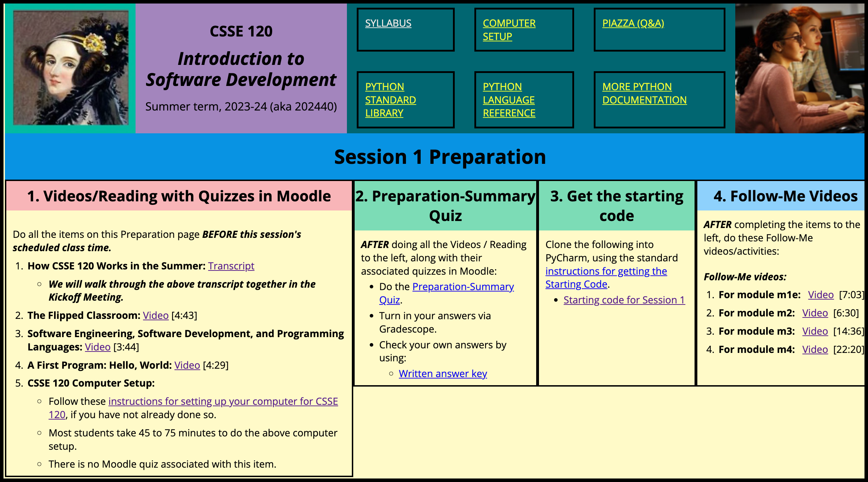
Pause the video until you have found that page, then resume the video.
Each unit has 5 parts, per the 4 columns on the unit’s web page plus a 5th implied column.
Here is a summary of the five parts; then I will walk you through each part in detail.
In part 1, you watch some videos and/or do some reading, and you do some Moodle quizzes while you do so.
In part 2, you do a quiz that summarizes the “preparation” work that you just did (via the videos/quizzes).
In part 3, you get the starting code for the coding that you will do for the unit.
In part 4, you watch some “Follow-Me” videos, following along and coding in the starting code as the videos direct.
Finally, in part 5, you do the remaining coding for the unit, per the directions in the starting code.
Most students take about 1 to 2 hours to do parts 1 to 4 and another 2 to 3 hours to do part 5, for a total of about 4 hours per unit. The first few units are a bit longer than that, however.
Let’s run through all 5 parts for Unit 1, one by one, in detail.
In part 1, you watch videos, just like you are doing now, and/or do reading. While you are watching the videos or doing the reading, you take quizzes in Moodle. The questions in the quiz follow the same order as the corresponding video.
So, right now, return to Moodle, right now, and find the quiz associated with this first video/transcript, just like I am doing here. Pause the video/transcript, then resume when you have found that quiz.
Go ahead and do the first question (but JUST the first question) in that quiz, right now, just like I am showing here. Pause the video, then resume when you have completed question 1 of the quiz.
After doing each question, you press the Check button to get instant feedback. Do so now, so that you see how that works.
Hopefully you chose the right answer to question 1, as I am showing here. But NO WORRIES if you get a question wrong. You get FULL CREDIT for any good-faith effort at each quiz, regardless of your score on the quiz. The quizzes help you absorb the material of the videos/reading; they are not intended to be difficult.
While you are watching the rest of this video/transcript, continue taking this quiz. The questions follow the same order as the video’s material, so you should easily see when to do each question.
So again, in part 1 of each quiz, you watch some videos and/or do some reading, and you do some Moodle quizzes while you do so, just like you are doing now.
Let’s imagine that you have completed the videos and associated quizzes for Unit 1. (In fact, you will do the rest of the videos AFTER you complete this video, BEFORE continuing to Part 2 of Unit 1; this video/transcript simply shows the process.)
In part 2 of each unit, you do a preparation-summary quiz that summarizes the “preparation” work that you just did (via the videos/quizzes). You find the preparation summary quiz in the second column of the unit’s web page. You can:
- Print the quiz and write your answers on the quiz (that is usually the easiest approach), or
- Type your answers into a file (while reading the quiz questions on your screen), or
- Hand-write your answers on a sheet of paper.
Whatever is easiest for you.
AFTER you answer the preparation-summary quiz questions, you check your OWN answers via the answer key that appears in the second column of the unit’s web page, just below the quiz itself.
Finally, you turn in your answers to the preparation-summary quiz by turning in your work on Moodle, as I am demonstrating here.
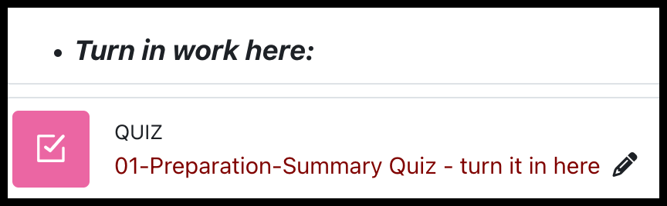
You don’t have to correct any mistakes that you may have made in the quiz; just turn in your answers (after checking them yourself). You get full credit for any good-faith effort at each preparation-summary quiz, regardless of your score.
Again, don’t do the preparation-summary quiz now; finish watching this video/transcript, answering the questions in its associated online quiz, and then do the remaining items in column 1 of the unit’s web page, and only then turn to the preparation-summary quiz in column 2.
Let’s imaging that you have completed the preparation-summary quiz in column 2 of the unit’s web page, checked your answers, and turned in your answers via Moodle. You then turn to column 3, where you will get the starting code for the unit. You follow the instructions that are linked, just like I am doing now. (Again, don’t DO this yet, but come back to it when you have completed columns 1 and 2 of the unit.)
[Read the instructions at the link, doing the steps as you do so]
Now, let’s imaging that you have cloned the starting code for the unit. This gives you a COPY (actually, what’s called a FORK) of the starting code; everyone starts with the same starting code but then augments that starting code per the instructions that appear in the starting code.
You then reach column 4 of the unit’s web page, where you watch some “Follow-Me” videos, following along and coding in the starting code as the videos direct. In unit 1, there are 4 Follow-Me videos. You just work through them, one by one. The first of the Unit 1 videos explains how you do so.
Finally, after you have completed columns 1 through 4 of the unit’s web page, you COMPLETE THE CODING per the instructions in the starting code. The Follow-Me videos for Unit 1 will explain how you do so, but I want to emphasize that you are not done with a unit until you have completed ALL the modules that you will see in the starting code, not just the ones that have Follow-Me videos associated with them. Again, the Follow-Me videos for Unit 1 will lead you through this process.
In summary, for each unit, you find the unit in Moodle, then follow the link to the unit’s web page. That page has 4 columns, per the parts for doing the unit:
- In part 1, you watch some videos and/or do some reading, and you do some Moodle quizzes while you do so.
- In part 2, you do a quiz that summarizes the “preparation” work that you just did (via the videos/quizzes).
- In part 3, you get the starting code for the coding that you will do for the unit.
- In part 4, you watch some “Follow-Me” videos, following along and coding in the starting code as the videos direct.
- Finally, in part 5, you do the remaining coding for the unit, per the directions in the starting code.
Most students take about 1 to 2 hours to do parts 1 to 4 and another 2 to 3 hours to do part 5, for a total of about 4 hours per unit. However, be aware that in the first few units, parts 1 to 4 are somewhat longer than is typical.

The course calendar lists dates for each unit. You do the units on those dates, or you can work ahead, or you can fall a little behind. The key is to finish each unit by the end of the day scheduled for that unit, or at least not more than 48 or so hours later. (But see the Catch-up Week.)
The key to keeping up with the work is to NOT get STUCK: If you are spending more than a few minutes on any coding problem, STOP at that point and GET HELP FROM ME.
You can get help from me in any of 3 ways:
- If I appear to be online on Microsoft Teams, message me to see if I am available. If so, we’ll do a quick call to answer your question right away.
- Or, if I don’t seem to be immediately available but you have a well-defined question, use our question-answering tool called Piazza to ask a question. This is better than email because EVERYONE can learn from your question. We will demonstrate Piazza during our live Kickoff session in Microsoft Teams before the first unit.
- Or, if you feel lost or simply want my help on any problems, email me and we will arrange a session in Microsoft Teams.
I am happy to meet with students; don’t hesitate to reach out!

To finish off our Kickoff session, we will:
- Sign up for TENTATIVE times for the Thursday 20-minute meetings.
- Sign up and try out Piazza.
- Complete Unit 1.

